KEMH Alumni Presents

“A 100 Years of the Country Women’s Association of WA”


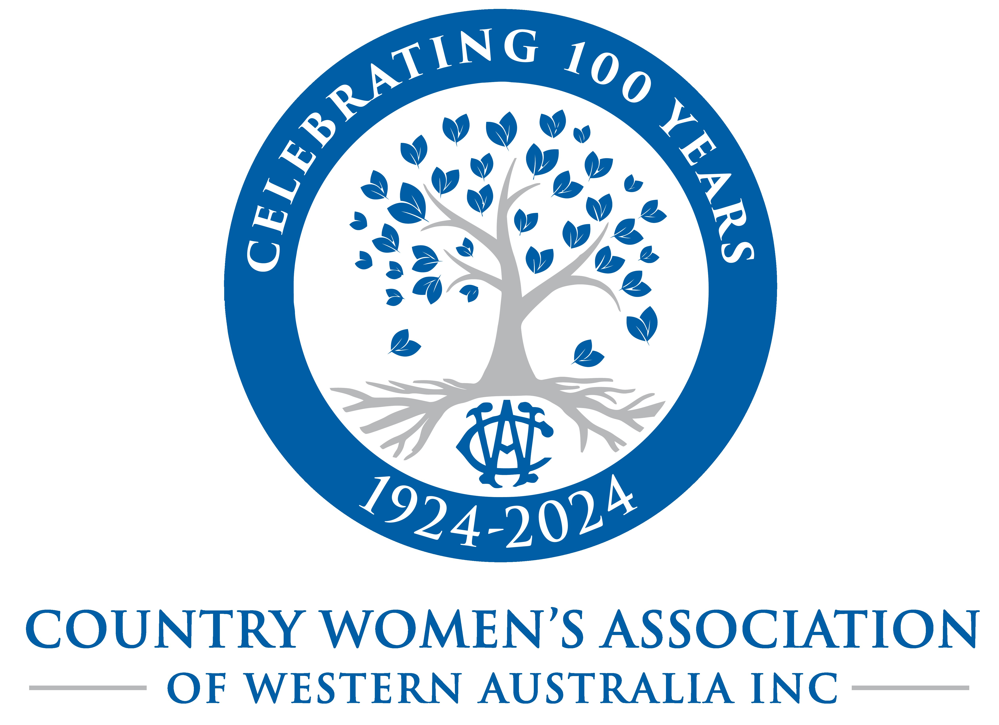

Presenter: Megan Depiazz
CWA Membership Engagement Officer
Thursday 16th May 2024
Venue: KEMH 374 Bagot Road Subiaco
Agnes Walsh Lounge

1800: Registration and refreshments provided
1830: Presentation
Entry: $10 – all welcome – bring a friend
RSVP to KEMH.Alumni@outlook.com

